Pre-Calculus Quiz 3.4/3.4a

For numbers 1 – 3:

a) identify the parent function in terms of f(x)

b) describe the transformation in words

c) graph the transformation with its parent function and label each graph.

1. g(x) =  2. g(x) =  3. g(x) = 

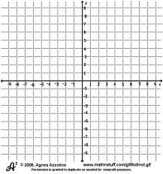

4. Write the equation for the function that is described by the given characteristics.

“the shape of f(x) = is moved three units to the right , four units down, reflected over the x-axis, and dilated vertically by two”.

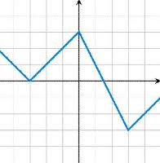For 5 and 6, use the graph to graph g(x) and h(x)

5. g(x) = f(x) - 3

6. h(x) = 2 f(x) +1

7. Determine if the graph is symmetric to the x-axis, y-axis, or origin (show your work)

a) 

b) 

8. Determine if the equation is even, odd, or neither (show your work)

a) 

b) 